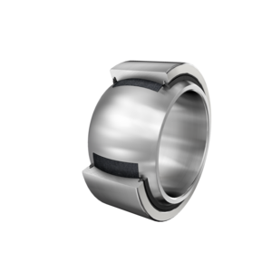

GE220-UK-2RS-B
Spherical plain bearing
Radial spherical plain bearing, maintenance-free, sliding layer: ELGOGLIDE, inner ring curved surface with hard chromium coating; DIN ISO 12240-1; dimension series E, sealed
Add to wish list
Contact us
Product informationCalculationsCADMounting
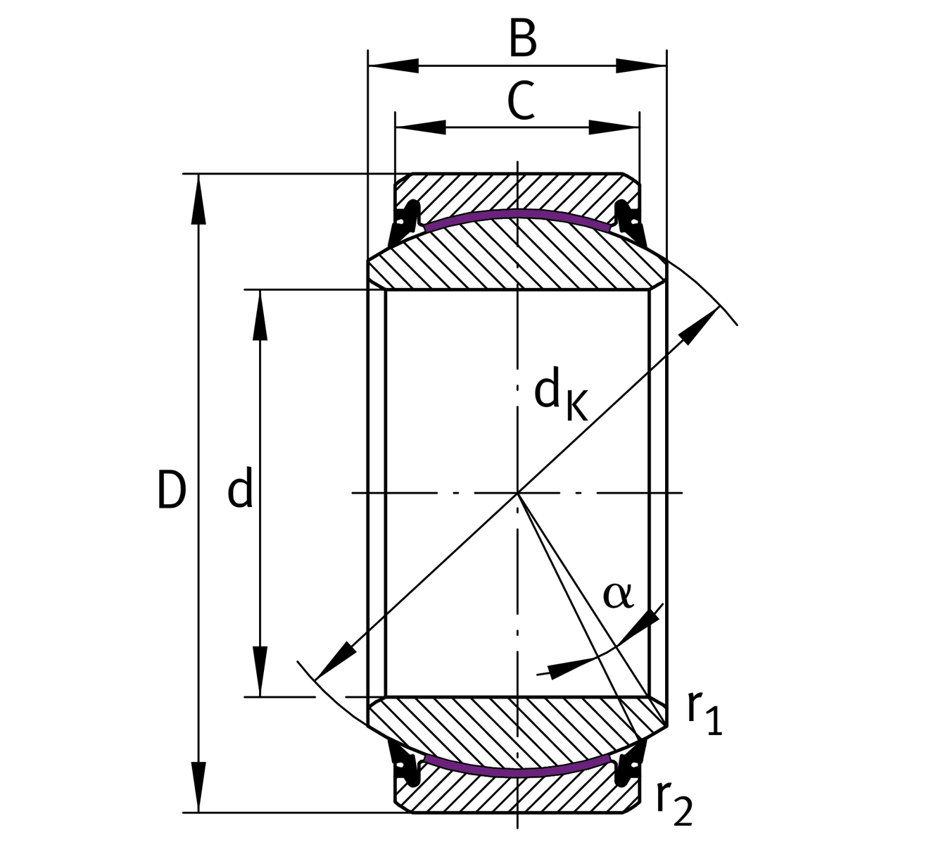
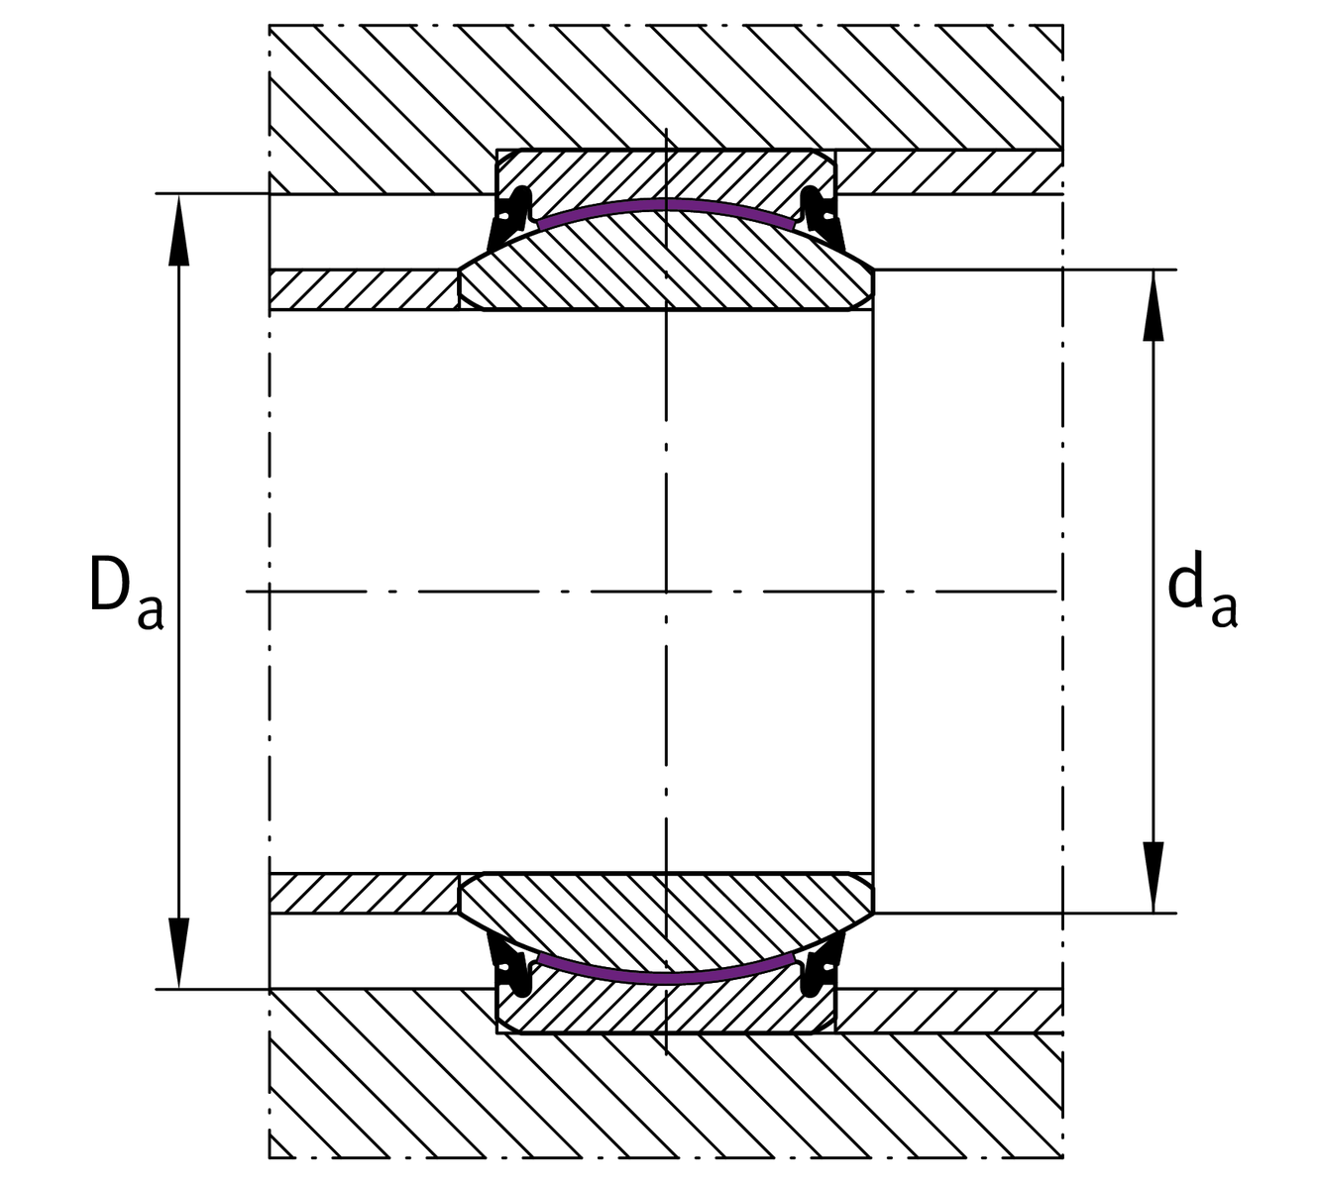
Main Dimensions & Performance DataDownload data sheet
D
320 mm
Outside diameter bearing
d
220 mm
Bore diameter bearing
B
135 mm
Width Inner ring
C
100 mm
Width Outer ring
C_{r}
6,600,000 N
Basic dynamic load rating, radial
C_{0r}
11,000,000 N
Basic static load rating, radial
32 kg
Weight
Dimensions
d_{K}
275 mm
Ball diameter
α
8 °
Tilt angle
G_{r}
0 - 0,11 mm
Radial Clearance
d_{UT}
-0.03 mm
Bore diameter bearing, lower tolerance
D_{UT}
-0.04 mm
Outside diameter, lower tolerance
B_{UT}
-0.3 mm
Width inner ring, lower tolerance
C_{OT}
-0.8 mm
Width outer ring, lower tolerance
Mounting dimensions
r_{1smin}
1.1 mm
Edge Spacing
r_{2smin}
1.1 mm
Edge Spacing
d_{a max}
239.5 mm
Connection measure Inner ring
D_{a min}
267 mm
Housing Connection Diameter
Temperature range
T_{min}
-30 °C
Operating temperature min.
T_{max}
130 °C
Operating temperature max.

